Owczarek Test Station (OTS)
User Manual

Table of contents
1 Introduction 3
2 User interface 4
3 Use cases 5
3.1 Start application 6
3.2 User log in 7
3.3 Start test session 8
3.3.1 Choose test method 8
3.3.2 Enter batch number 8
3.3.3 Click OK 8
3.4 Perform test run 9
3.4.1 Attach object to test into the fixture 9
3.4.2 Click START TEST RUN 9
3.4.3 Test is being executed 9
3.4.4 Test finishes 10
3.4.4.1 Test passed 10
3.4.4.2 Test failed 11
3.4.4.3 Test terminated 11
3.4.5 Start next test run or finish test session 11
3.4.6 Extra: statistics 12
3.5 Close application 13

Introduction
This document describes how to use OTS (Owczarek Test System). OTS is an application created to perform and evaluate automatic tests. It executes selected test method, evaluate results with limits and saves it into text report files.
The document explains elements of the user interface and instructs how to perform most common operations.

User interface
The user interface is divided into several areas – each responsible for specific task:
HEADER
- logo

USER
- user name
- log in box
RESULT
- test run intermediate results
- test run status
STATISTICS
- total statistics
- test run time

MESSAGE
- messages for operator
- actions that require
operator’s action

This is how it looks in the real application:
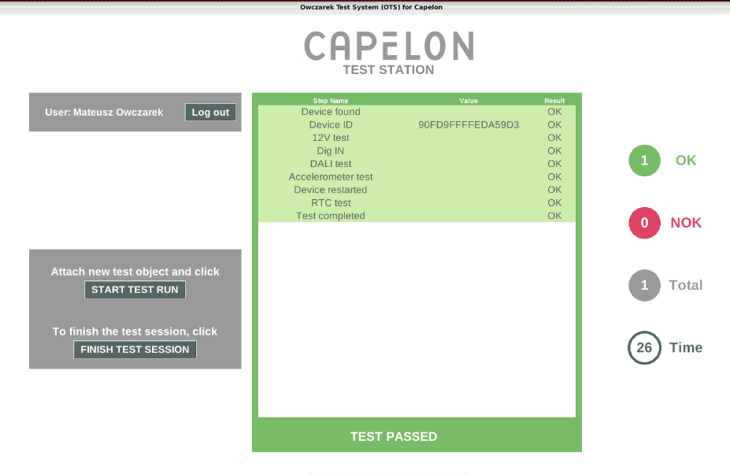
More specific explanation of particular interface elements is available in Use cases chapter in subchapter concerning this element.

Use cases

The most common use case involves:
3 Use cases 5
3.1 Start application 6
3.2 User log in 7
3.3 Start test session 8
3.4 Perform test run 9
3.5 Close application 13

They are described in subchapters below.

Start application
To start application, double-click its shortcut on the desktop
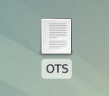

The application will be launched and the main screen will be displayed.

User log in
To perform any action, an authorized user must be logged in. To log in, enter login and password into log in box in the USER area.
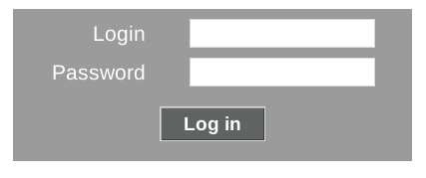
If credentials are correct, the authorization is finished succesfully and USER area displays the full name of the logged user:

Otherwise, the ‘wrong login or password’ message is displayed.

Start test session
To start a test session:

Choose test method
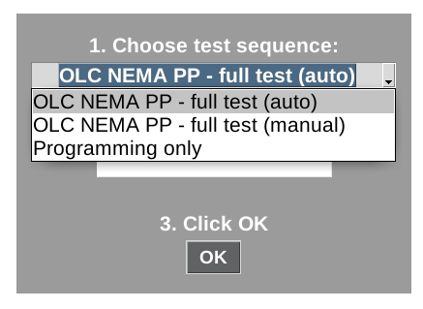
This field cannot be left blank.

Enter batch number
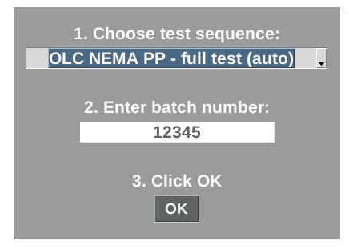

Click OK

Perform test run
When the test session is already started, you can start test run.
Following message is displayed.

To continue:

Attach object to test into the fixture

Click START TEST RUN

Test is being executed
In the RESULT area intermediate steps results are being displayed and updated.
At the bottom of this area there is a status bar displaing current status (IN PROGRESS, PASSED, FAILED, TERMINATED) and TERMINATE button.

MESSAGE area presents a short information about current actions or requests the operator to perform some actions.
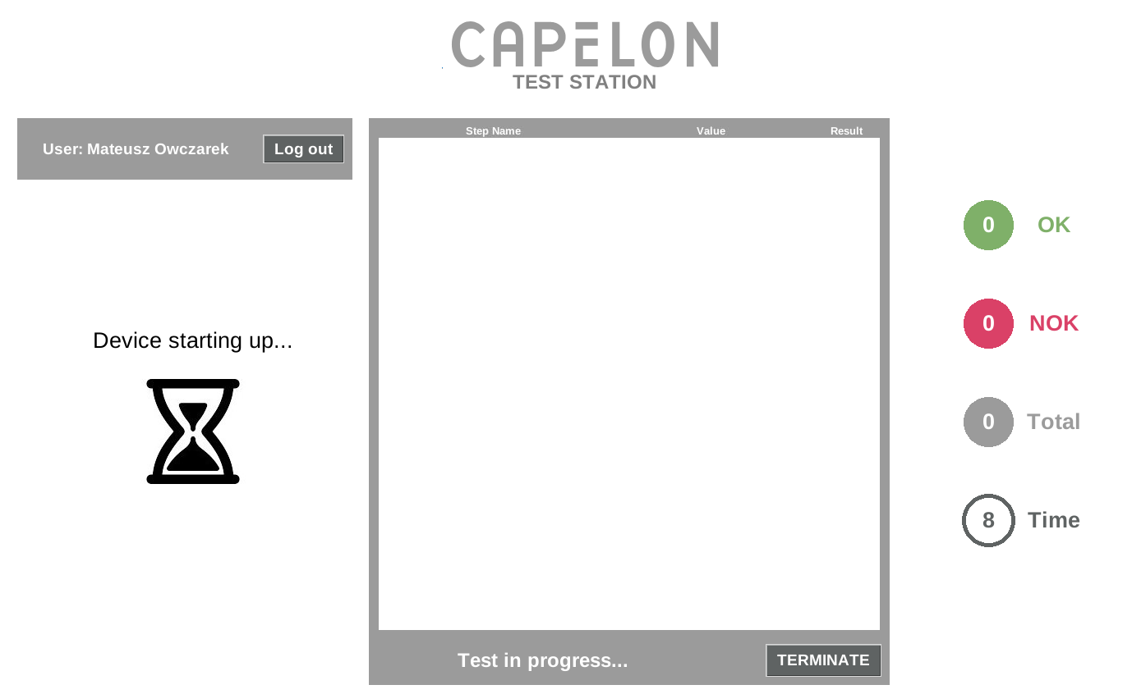

Test finishes
There may be several reasons of the test run to finish its execution:

Test passed
If test run finishes successfully, the RESULT area is highlighted green and appropriate test run status is being displayed.
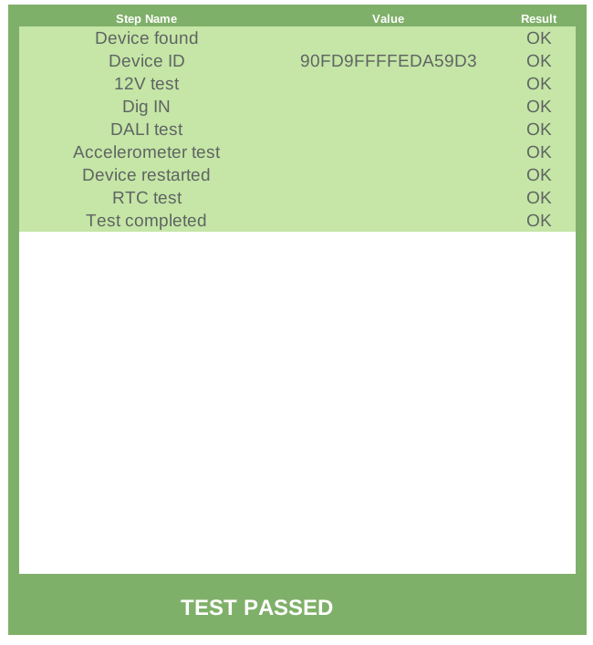

Test failed
If test run fails, the RESULT area is highlighted red (excluding intermediate steps that passed) and appropriate test run status is being displayed.
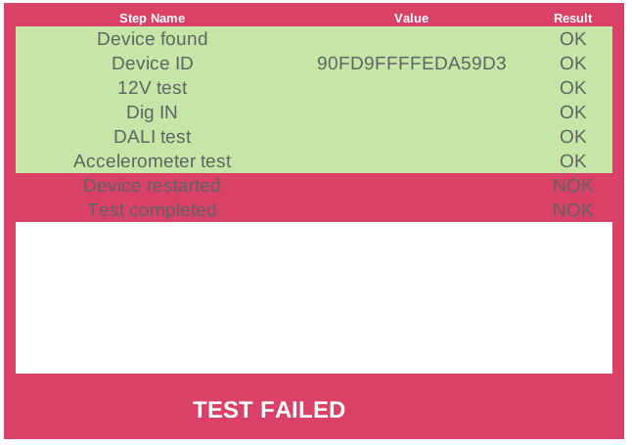

Test terminated
To terminate current test run during it execution, click TERMINATE button. The test stops and displays appropriate message:


Start next test run or finish test session
When the test run is over, the following message box displays:
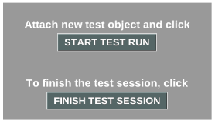
To start next test run, remove the tested object from the fixture and follow again instructions from chapter Perform test run
To finish the current test session, click FINISH TEST SESSION. When the session is finished you can start a new one with different test method and/or batch number (follow instructions from chapter Start test session

Extra: statistics
In the STATISTICS area there are four statistics being dynamically updated:
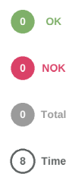 | - number of total passed (OK) test runs
 | - number of total failed or terminated (NOK) test runs
 | - number of total test runs
 | - time [s] of the current test time

Close application
To close the application click X button in the top right corner of the window.
It will:
- terminate the current test run (if any)
- end the test session (if started)
- log out user (if logged)
- close the application

